ML Lab 3

Name: Saptanshu Wanjari

Class: C1-A2

Roll No: 18
Lab No.: 3
Lab Aim and Objective: To implement Simple Linear Regression on the USA Housing dataset, predict house prices using the Avg. Area Income feature, and then tune the LinearRegression model with GridSearchCV to find the best hyperparameters.
Dataset or Resources Used: USA_Housing.csv (5000 rows, 7 columns). Tools: Python 3.12, Jupyter Notebook, pandas, numpy, matplotlib, seaborn, scikit-learn.
Date of Performance: 22 July 2026

1. Theory

1.1 What is Simple Linear Regression?
Simple Linear Regression is a supervised machine learning algorithm used for regression problems. It finds a straight line relationship between one independent variable (X) and a dependent variable (y). The line is given by y = mx + c, where m is the slope and c is the intercept. Here we use Avg. Area Income as X and Price as y.

1.2 What is Hyperparameter Tuning?
Hyperparameters are the settings of a model that we decide before training, like fit_intercept or positive in LinearRegression. GridSearchCV tries all the combinations of the given hyperparameters using cross validation and returns the combination that gives the best score. This way we do not have to guess the settings by hand.

1.2 Techniques Applied
• Loaded and inspected the data with head, tail, shape, columns, info and describe.
• Checked for missing values and duplicates (both are zero).
• Dropped the Address column as it is text and not useful.
• Did EDA with histplots, a scatter plot, box plot and correlation heatmap.
• Found 32 outliers in Avg. Area Income using the IQR method.
• Split the data into train (4000) and test (1000) with 20% test size.
• Trained a LinearRegression model and evaluated it with MAE, MSE, RMSE and R2 score.
• Tuned the model with GridSearchCV to find the best parameters.

2. Code with GitHub URL
The complete code for this lab is written in a Jupyter Notebook and uploaded to GitHub:
https://github.com/SaptanshuWanjari/3rd-Year-/blob/main/ML/lab/22-7-Lab-3/C1_A2_18-Saptanshu_Wanjari-Lab-3.ipynb
https://github.com/SaptanshuWanjari/3rd-Year-/blob/main/ML/lab/22-7-Lab-3/C1_A2_18-Saptanshu_Wanjari-Lab-3.py
The complete written code is given below:
#!/usr/bin/env python
# coding: utf-8
# # ML Lab 3
# ## Name: Saptanshu Wanjari
# ### Class: C1-A2
# ### Roll No: 18
# In[1]:
import numpy as np
import pandas as pd
import matplotlib.pyplot as plt
import seaborn as sns
from sklearn.model_selection import train_test_split, GridSearchCV
from sklearn.linear_model import LinearRegression
from sklearn.metrics import mean_absolute_error, mean_squared_error, r2_score
# In[2]:
df = pd.read_csv("USA_Housing.csv")
df.head()
# In[3]:
df.tail()
# In[4]:
df.shape
# In[5]:
df.columns
# In[6]:
df.info()
# In[7]:
df.describe()
# In[8]:
df.isnull().sum()
# In[9]:
df.duplicated().sum()
# In[10]:
if 'Address' in df.columns:
df.drop('Address', axis=1, inplace=True)
print(df.shape)
# ## EDA
# In[11]:
plt.figure(figsize=(8,5))
sns.histplot(df['Price'], kde=True)
plt.title('Distribution of House Price')
plt.show()
# In[12]:
plt.figure(figsize=(8,5))
sns.histplot(df['Avg. Area Income'], kde=True)
plt.title('Distribution of Avg. Area Income')
plt.show()
# In[13]:
sns.scatterplot(x='Avg. Area Income', y='Price', data=df)
plt.title('Avg. Area Income vs Price')
plt.show()
# In[14]:
plt.figure(figsize=(10,6))
corr_matrix = df.corr()
sns.heatmap(corr_matrix, annot=True, cmap='coolwarm', fmt='.2f', linewidths=0.5)
plt.title('Feature Correlation Matrix')
plt.show()
# In[15]:
sns.boxplot(x=df['Avg. Area Income'])
plt.title('Box plot of Avg. Area Income')
plt.show()
# In[16]:
# IQR method to find outliers in Avg. Area Income
q1 = df['Avg. Area Income'].quantile(0.25)
q3 = df['Avg. Area Income'].quantile(0.75)
iqr = q3 - q1
lower = q1 - 1.5 * iqr
upper = q3 + 1.5 * iqr
outliers = df[(df['Avg. Area Income'] < lower) | (df['Avg. Area Income'] > upper)]
print('Q1:', q1)
print('Q3:', q3)
print('IQR:', iqr)
print('Lower bound:', lower)
print('Upper bound:', upper)
print('Number of outliers:', len(outliers))
# ## Simple Linear Regression
# In[17]:
X = df[['Avg. Area Income']]
y = df['Price']
# In[18]:
X_train, X_test, y_train, y_test = train_test_split(X, y, test_size=0.2, random_state=42)
print('Train shape:', X_train.shape)
print('Test shape:', X_test.shape)
# In[19]:
slr_model = LinearRegression()
slr_model.fit(X_train, y_train)
# In[20]:
y_pred = slr_model.predict(X_test)
# In[21]:
MAE = mean_absolute_error(y_test, y_pred)
MSE = mean_squared_error(y_test, y_pred)
RMSE = np.sqrt(MSE)
R2 = r2_score(y_test, y_pred)
print('Simple Linear Regression Results')
print('--------------------------------')
print('MAE: ', MAE)
print('MSE: ', MSE)
print('RMSE: ', RMSE)
print('R2 Score:', R2)
# In[22]:
print('Intercept: ', slr_model.intercept_)
print('Slope: ', slr_model.coef_[0])
# In[23]:
plt.figure(figsize=(8,6))
plt.scatter(X_test, y_test, color='blue', label='Actual Data')
plt.plot(X_test, y_pred, color='red', linewidth=2, label='Regression Line')
plt.xlabel('Avg Area Income')
plt.ylabel('House Price')
plt.title('Simple Linear Regression')
plt.legend()
plt.show()
# In[24]:
income = 80000
new_data = pd.DataFrame({"Avg. Area Income":[income]})
prediction = slr_model.predict(new_data)
print("Predicted House Price for income $80,000: $ {:,.2f}".format(prediction[0]))
# ## Hyperparameter Tuning with GridSearchCV
# In[25]:
lr = LinearRegression()
lr_params = {
'fit_intercept': [True, False],
'positive': [True, False]
}
grid_search = GridSearchCV(estimator=lr, param_grid=lr_params, cv=5, scoring='r2', n_jobs=-1)
grid_search.fit(X_train, y_train)
print('Best Parameters: ', grid_search.best_params_)
print('Best Cross Validation Score: ', grid_search.best_score_)
# In[26]:
best_model = grid_search.best_estimator_
print(best_model)
# In[27]:
y_pred_best = best_model.predict(X_test)
MAE = mean_absolute_error(y_test, y_pred_best)
MSE = mean_squared_error(y_test, y_pred_best)
RMSE = np.sqrt(MSE)
R2 = r2_score(y_test, y_pred_best)
print('Best Model Results')
print('------------------')
print('MAE: ', MAE)
print('MSE: ', MSE)
print('RMSE: ', RMSE)
print('R2 Score:', R2)

3. Procedures and Materials Used

3.1 Materials Used
• Hardware: A laptop with any OS (Windows/Linux).
• Software: Python 3.12, Jupyter Notebook, pandas, numpy, matplotlib, seaborn, scikit-learn.
• Dataset: USA_Housing.csv downloaded from Kaggle.

3.2 Procedure
1. Load the USA_Housing.csv file using pandas read_csv.
2. Inspect the data using head, tail, shape, columns, info and describe.
3. Check for missing values and duplicates with isnull and duplicated.
4. Drop the Address column because it is text and not useful for prediction.
5. Plot EDA graphs like histplots, scatter plot, box plot and correlation heatmap.
6. Find outliers in Avg. Area Income using the IQR method.
7. Separate X (Avg. Area Income) and y (Price), then split into train and test with 20% test size.
8. Train a LinearRegression model on the training data.
9. Predict on the test data and evaluate using MAE, MSE, RMSE and R2 score.
10. Tune the model with GridSearchCV and compare the best model results.

4. Output Screenshots with Descriptions

Output 1 – First 5 rows of the dataset
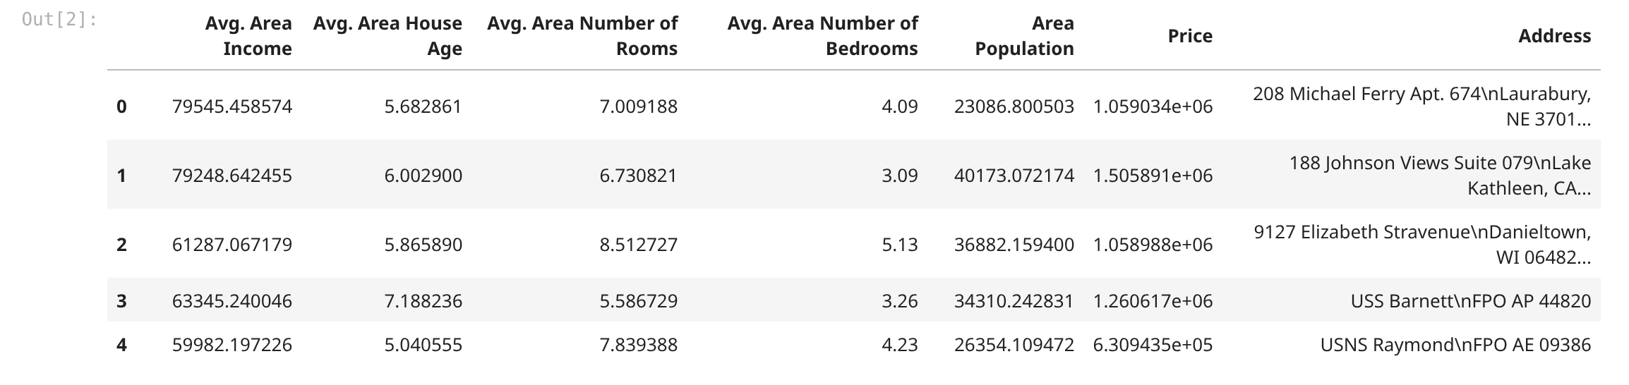
First 5 rows of the data. You can see there are 7 columns and 5000 rows total. All the columns except Address are numbers, so we can use them directly.

Output 2 – Dataset info
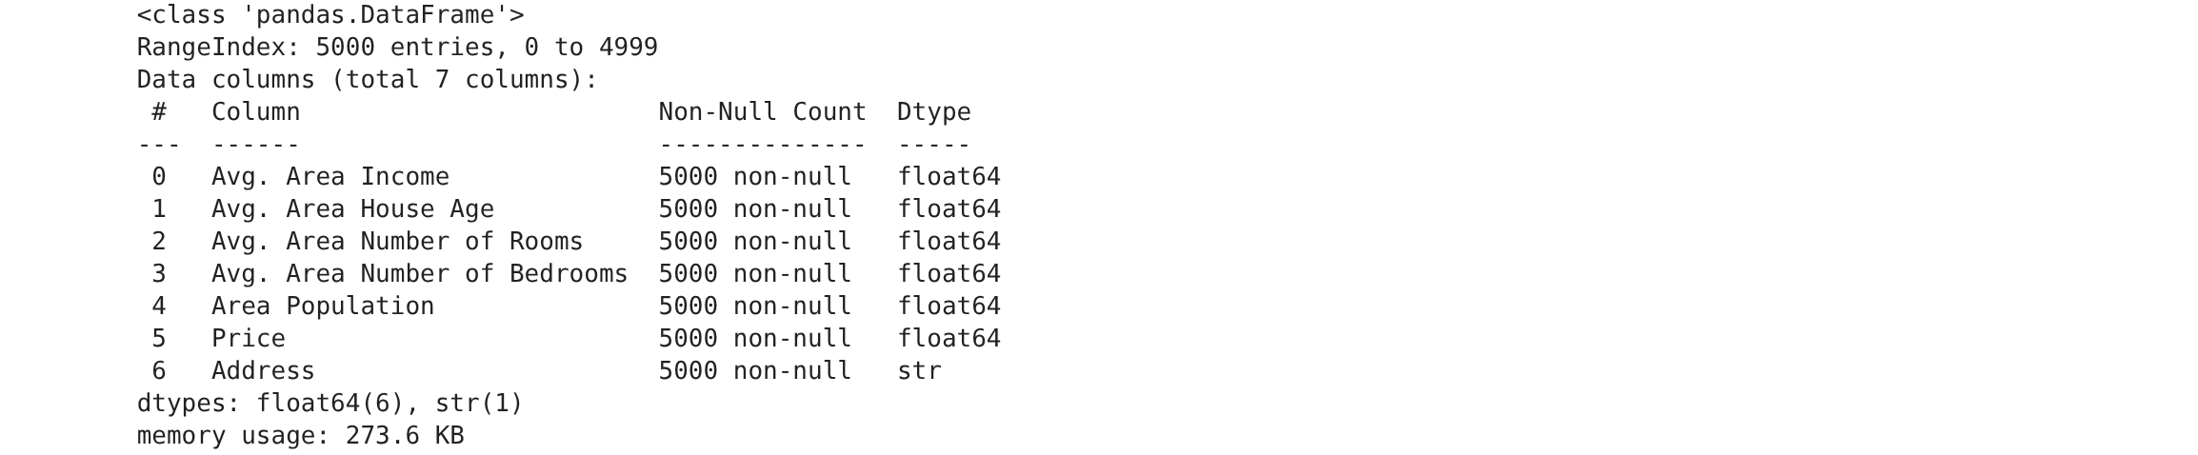
df.info() shows all the columns and their data types. All 7 columns have 5000 non-null values, so there are no missing values. Address is the only object type column, the rest are float64.

Output 3 – Missing values check
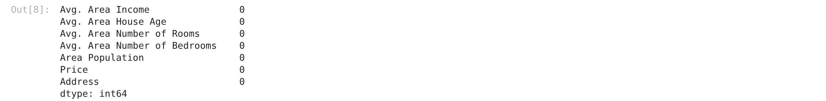
Checking for missing values. Every column shows 0, so the dataset is clean and we don't need to fill anything.

Output 4 – Correlation heatmap
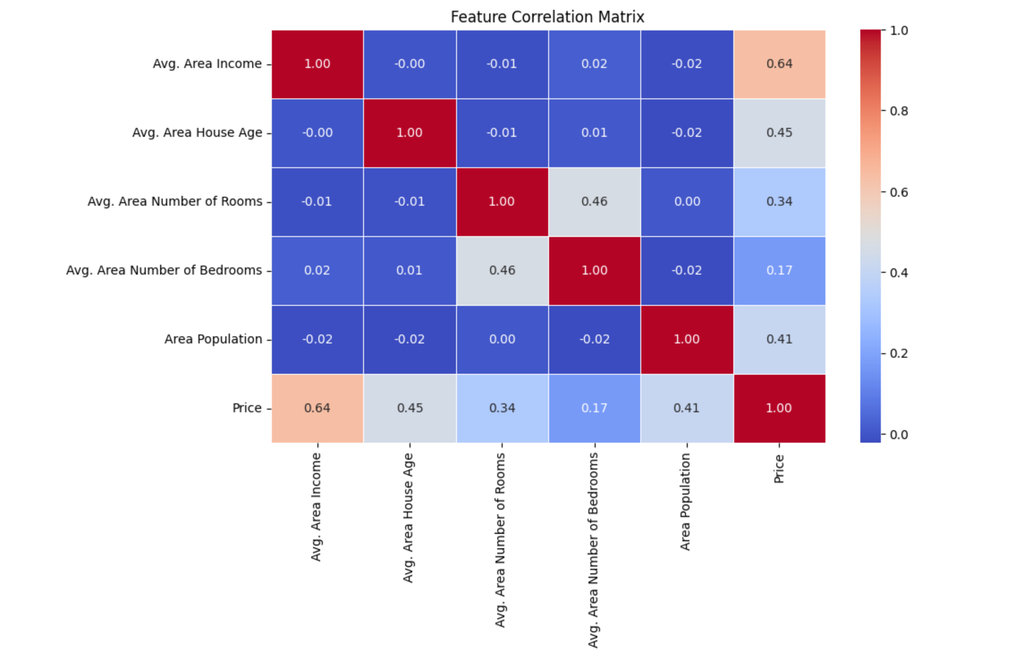
Correlation matrix as a heatmap. Income has the highest correlation with Price at 0.64. House age and population also have some positive correlation, around 0.45 and 0.41.

Output 5 – Distribution of house price
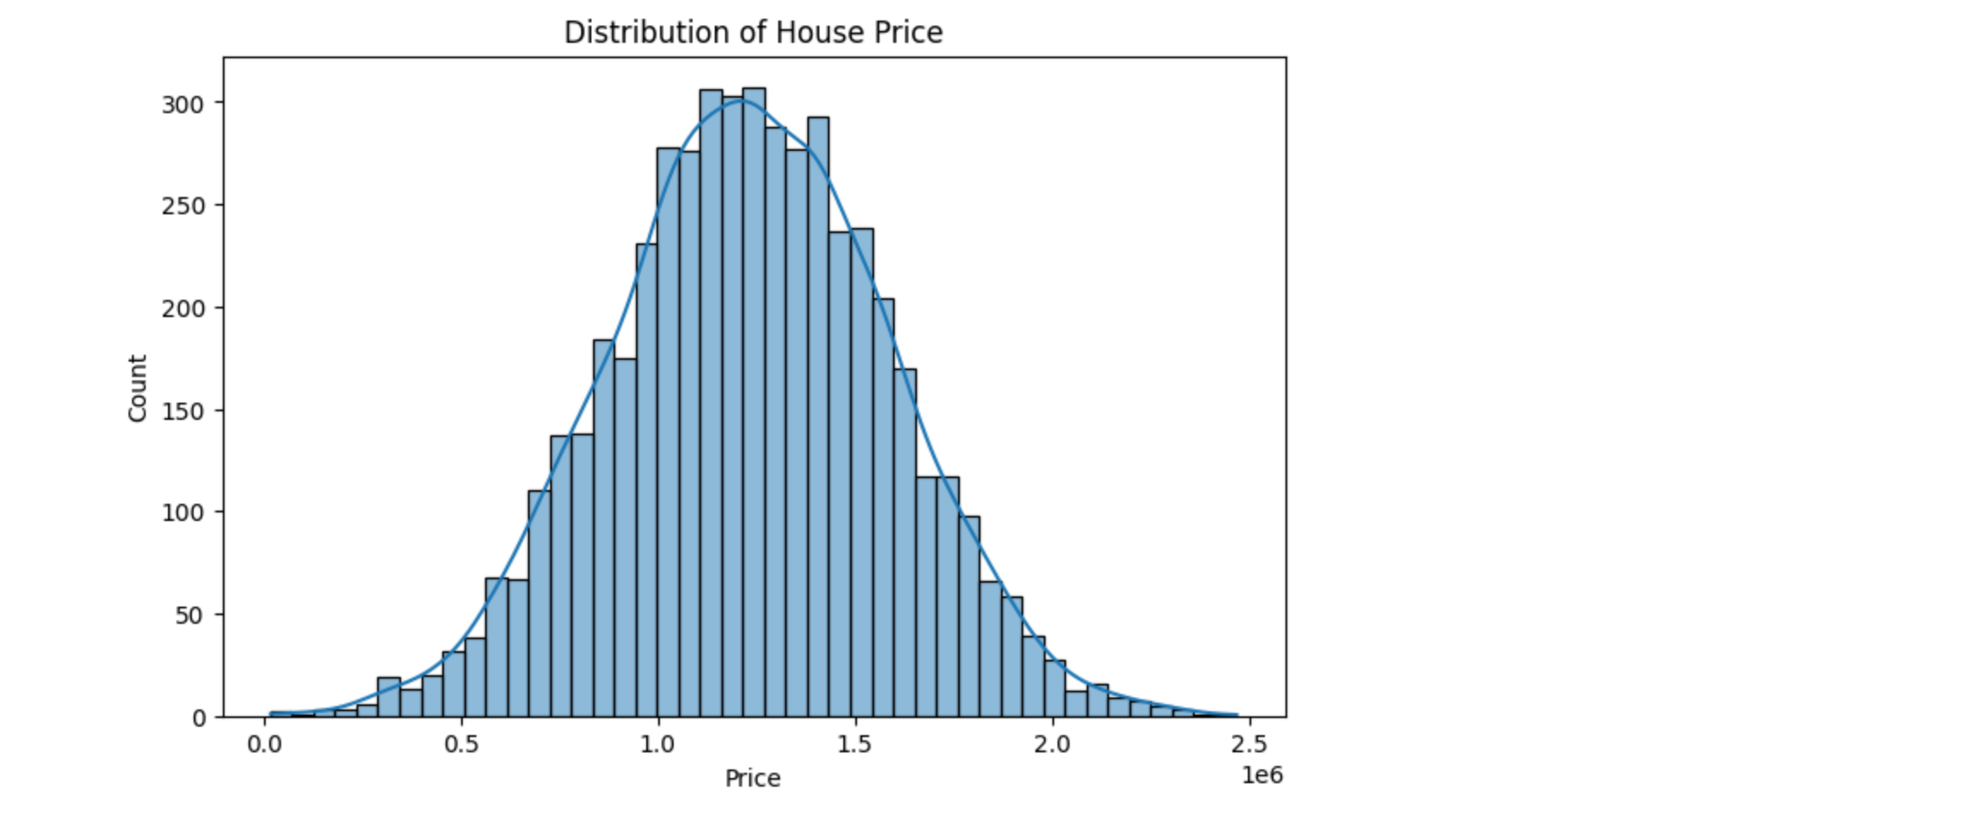
Histogram of house price with a KDE curve. The distribution is roughly bell shaped, most houses cost somewhere in the middle and fewer houses are very cheap or very expensive.

Output 6 – Income vs price scatter plot
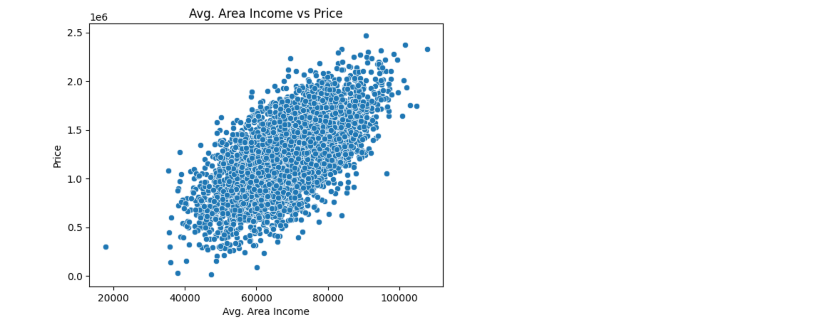
Scatter plot of income against price. The points go up from left to right, so higher income areas tend to have higher house prices.

Output 7 – IQR outlier detection
IQR method for outliers in Avg. Area Income. Q1 is 61480 and Q3 is 75783 so the IQR is 14302. There are 32 outlier rows that fall outside the bounds.

Output 8 – SLR evaluation metrics
The evaluation results of the simple linear regression model. MAE is around 216826, RMSE is 272387 and R2 score is 0.39. So the model explains about 39% of the variation in price.

Output 9 – Regression line on test data
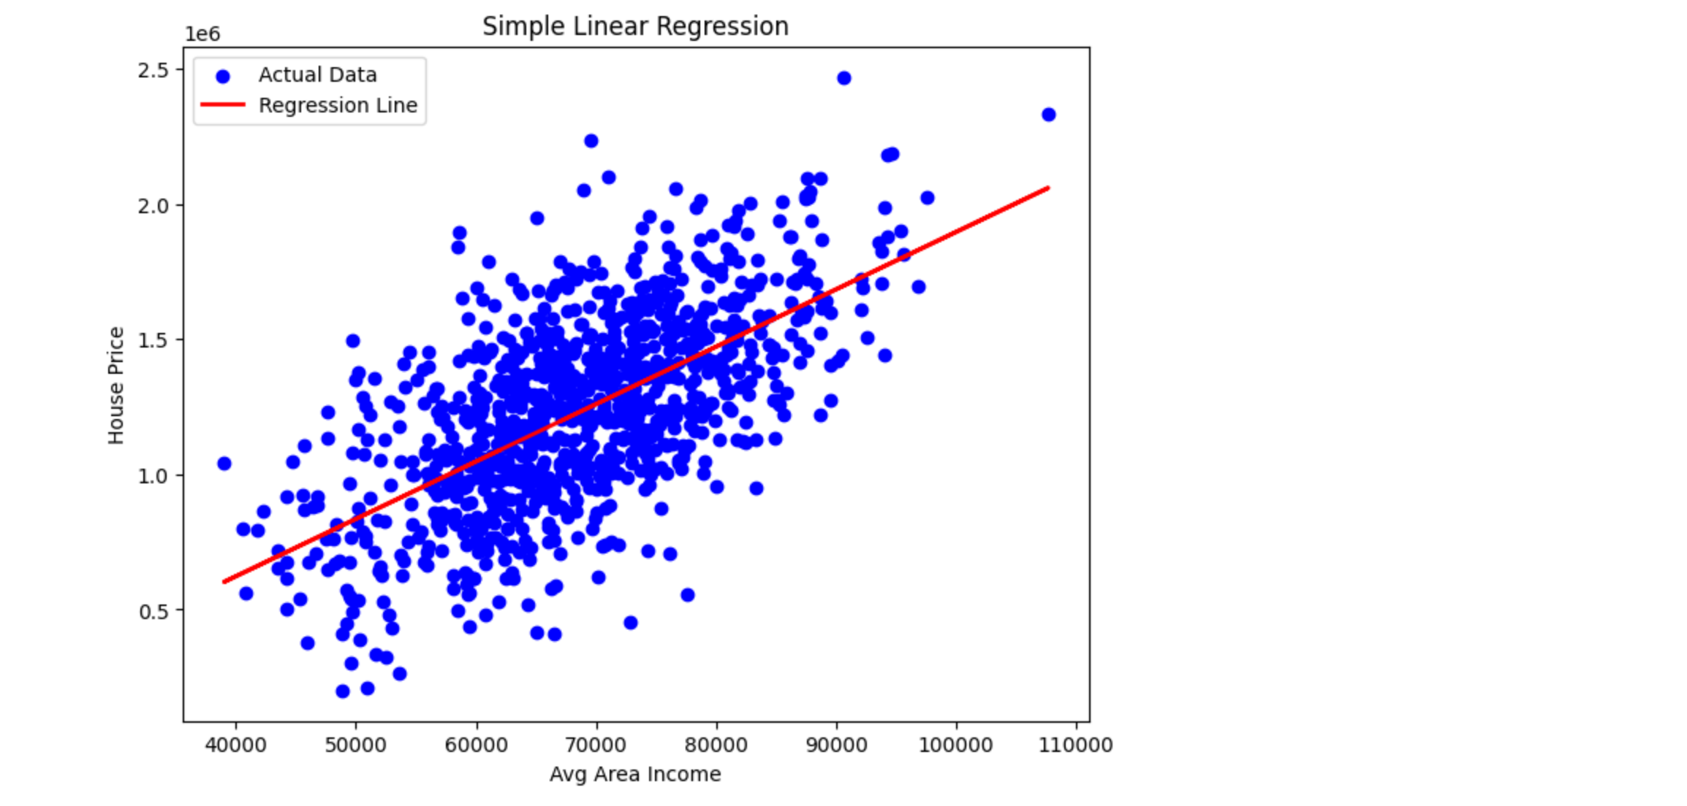
The regression line plotted over the test points. The red line rises with the blue actual points, so the model is capturing the trend, though the points are scattered far from the line.

Output 10 – GridSearchCV best parameters
GridSearchCV output. The best parameters are fit_intercept True and positive True, with a cross validation score of 0.41. So positive True improved the score slightly compared to the plain model.

5. Viva Questions and Solutions
Q1. What is Simple Linear Regression?
Solution: Simple Linear Regression is a supervised algorithm that predicts a continuous output using one independent variable. It fits a straight line y = mx + c that minimizes the error between the actual and predicted values.
Q2. What is the difference between simple and multiple linear regression?
Solution: Simple linear regression uses only one independent variable, like income here, while multiple linear regression uses two or more variables like income, house age, rooms and population together.
Q3. What are MAE, MSE, RMSE and R2 score?
Solution: MAE is the average of absolute errors, MSE is the average of squared errors and RMSE is the square root of MSE. R2 score tells how much of the variance in y the model explains, between 0 and 1.
Q4. What is GridSearchCV and why did we use it?
Solution: GridSearchCV tries every combination of the hyperparameters given in a grid and uses cross validation to score each one. We used it to find the best fit_intercept and positive values for LinearRegression instead of setting them manually.
Q5. What did the best parameters mean in this lab?
Solution: The best parameters were fit_intercept True and positive True. fit_intercept True means the model includes the intercept term, and positive True means the coefficients are kept positive, which makes sense for house prices.

